**K23-0593**

**Muhammad Ayesh**

**Lab-3-A**

**Task-1:**

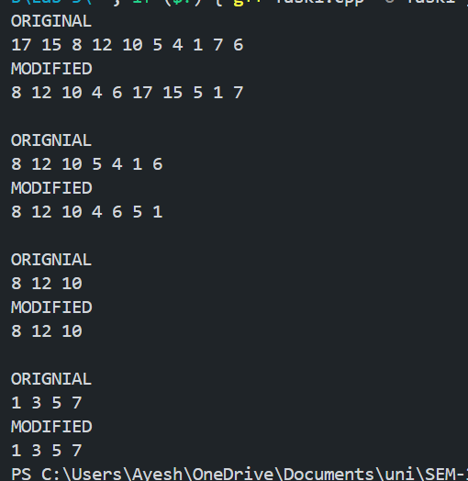

**Task-2:**

**Task-3:**

